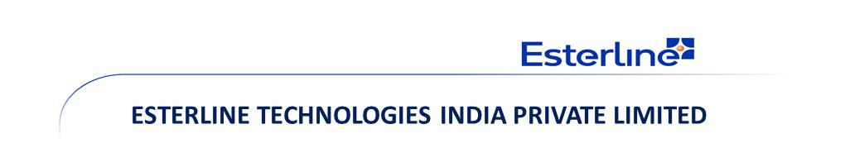Prestige Blue Chip Software Park, Block-1, Level-4, No.9, Hosur Road, Bangalore 560029, Karnataka, India.

**Task Tracker Tool Requirements Document**

**Document ID: EINQ-OOOO-QMTPT-0001**

**Revision: 0.1**

**Date: 31 July 2017**

|  |  |  |
| --- | --- | --- |
| Prepared by:  Anirban Biswas | Reviewed by: | Approved by: |
| Date: 15/01/2017 | Date: | Date: |
|  | | |
| Disclaimer  The official controlled copy of this procedure is the signed PDF document on the Esterline Technologies India network server, and is available to all authorized users. All other printed or electronic copies and versions are considered uncontrolled copies used for reference only.  This document contains no controlled technical data or technology. | | |

**Revision History**

|  |  |  |
| --- | --- | --- |
| **Revision** | **Release Date** | **Description** |
|  |  |  |
|  |  |  |
|  |  |  |

**Table of Contents**

1 Purpose 4

2 Scope 4

3 Abbreviations, Terms and Definitions 4

4 Responsibility and Authority 4

5 Requirements Description 4

5.1 Functionality 1 4

5.2 Functionality 2 4

5.3 Functionality 3 4

5.4 Functionality 4 4

5.5 Functionality 5 4

# Purpose

This Requirement document covers the tracking of all tasks or work orders ranging from total work load received by Esterline, scheduling/planning, work allocation, current status, deliverable quantity and quality with all the KPI’s/Metrics.

This task tracker tool provides complete business growth of the organization with more efficiency and realistic way.

* Get the complete work load and monitor the status.
* Total deliverable quantities with quality.
* Generation of all KPI’s/Metrics for the project.
* SOP will be followed in linier motion.
* Elimination of using/tracking multiple excels related to the various ongoing as well as closed work order at the same time.
* Elimination of human error in excels and saves production time.

# Scope

This procedure is applicable to all Engineering Programs and Projects and Support teams (for QMS Internal/External Audits). In this requirement documents only Tech-Pub process is highlighted.

# Abbreviations, Terms and Definitions

|  |  |
| --- | --- |
| Abbreviation/Term | Definition |
| CMNTS | Comments |
| CSTMR | Customer |
| ILLU | Illustration |
| IO | Illustration Order |
| IR | Internal Review |
| OWNR | Owner |
| PR | Peer Review |
| QA | Quality Assurance |
| REVWR | Reviewer |
| SFCK | Self-Check |
| TTT | Task Tracker Tool |
| V&V | Verification and Validation |
| WIP | Work In Progress |
| WO | Work Order |

# Responsibility and Authority

|  |  |
| --- | --- |
| **Function / Departmental Manager** | The Function / Departmental Manager will update the tracker for received work order details, responsible Owner’s name, required SFCK date and planned delivery date to the customer. |
| **Technical Writer** | Technical Writer will accept the WO in TTT with date and will update the required parameters in all the phase of work with date till the work submits for review. |
| **Technical Illustrator** | Technical Illustrator will accept the WO with illustration details (raised by the Technical Writer) in TTT with date and will update the required parameters in all the phase of work with date till the work submits for review. |
| **Peer Reviewer** | Once OWNR (Technical Writer) submits the work in TTT, the WO will come to the Peer Reviewer’s bucket. Peer Reviewer will update the V&V tab with error code and description, if any. Then Peer Reviewer will send the work to the next level (for Internal Review) with date once it is ready. |
| **Technical Lead / Internal Reviewer** | Technical Lead / Internal Reviewer will update the V&V tab with error code and description, if any. Then Technical Lead / Internal Reviewer will send the work to the next level (External Review / Customer) with actual delivery date once it is ready. |

# 

# Functional Requirements Description

The requirements for the TTT are decomposed into five major pages as given below. The detailed requirements pertaining to each of these functions will be described in the respective sections.

Functions:

1. Unique Credentials
2. Editing Project
3. Associated WO
4. Associated ILLU
5. Report

The interface of the TTT will be as follows:

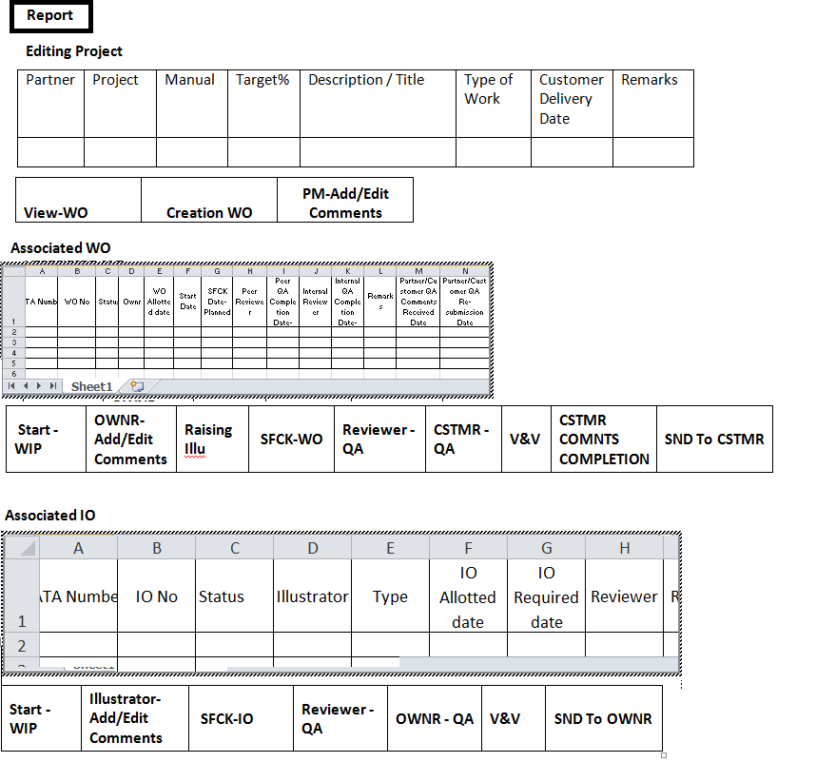

## Unique Credentials

All the resources will have unique credentials as per the respective project roles/responsibility and resources will have authorization for the specific tabs according to the roles/responsibility. This specific authorization will control any pre-set data manipulation/modification.

The unique credentials will have two drop down lists (drop down lists below) along with the “User Name” and “Password”.

1. Team (for the specific Team)
2. Roles (for the specific roles/responsibility)

|  |  |
| --- | --- |
| User Name |  |
| Password |  |
| Team | |
| Roles/Responsibility | |

## Editing Project

This page will be controlled by Function/Departmental Manager. But this page will be visible for other associated responsible resources to make the work plan. All the given attributes in tab will be displayed followed by the tabs.

This Editing Project page will appear as below:

## Editing Project

|  |  |  |  |  |  |  |  |
| --- | --- | --- | --- | --- | --- | --- | --- |
| Partner | Project | Manual | Target% | Description / Title | Type of Work | Customer Delivery Date | Remarks |
|  |  |  |  |  |  |  |  |

|  |  |  |
| --- | --- | --- |
| **View-WO** | **Creation WO** | **PM-Add/Edit  Comments** |

* **PM-Add/Edit Comments**: After receiving the work, Manager will update the **“PM-Add/Edit Comments”** tab. Once the tab is clicked the modify attribute dialog box will appear with all the parameters mentioned above.

In that dialog box “Customer Delivery Date” option shall open a calendar to freeze the customer delivery date.

Once all the attributes are filled, need to save the data.

All the fixed data and output will be appeared in a tabular format as shown above.

Only Manager will have access to this tab.

* **Creation WO:** Manager will update **“Creation WO”** tab for creation and allocation each work order along with planned SFCK, Planned PR Completion and Planned IR Completion date.

|  |  |  |
| --- | --- | --- |
| WO No. | |  |
| ATA Number | |  |
| OWNR | |  |
| WO Allotted date | |  |
| SFCK Date - Planned | |  |
| PR | |  |
| PR QA Completion Date - Planned | |  |
| IR | |  |
| IR QA Completion Date - Planned | |  |
| **ADD** | **EDIT** | **SUBMIT** |

WO Allotted date, SFCK Date – Planned, PR QA Completion Date – Planned and IR QA Completion Date – Planned option shall open a calendar to freeze the WO completion planned date in each phase.

Remaining attributes will have editable boxes to allow the Manager to enter the applicable WO No., ATA Number, Owner Name, PR Name and IR Name for the respective WO.

Manager will click **“ADD”** button to add and allocate the other WO’s in the same project.

Once the **“ADD”** button is clicked the respective WO details will add and visible in the “**Associated WO”** page.

Manager will click **“EDIT”** button to edit any preset WO details.

Manager will click **“SUBMIT”** button to fix the data.

Once **“SUBMIT”** button is clicked, the WO will be in the respective responsible resource’s bucket and the status of the WO will show as **“ALLOTTED”** in the “**Associated WO”** page.

* **View- WO:** This tab will allowapproachingthe specific work order details and it will display in the “**Associated WO”** page.

According to the WO allocation, the WO No. will be displayed for the respective resources.

## Associated WO

This page will display the complete overview and status of each work order in a tabular format.

**Associated WO** page will display as below:

**Associated WO**



|  |  |  |  |  |  |  |  |  |
| --- | --- | --- | --- | --- | --- | --- | --- | --- |
| **Start -WIP** | **OWNR-Add/Edit Comments** | **Raising Illu** | **SFCK-WO** | **Reviewer - QA** | **CSTMR - QA** | **V&V** | **CSTMR COMNTS COMPLETION** | **SND To CSTMR** |

* **Start -WIP:** Once the work is assigned, the OWNR/Technical Writer shall accept the WO by clicking the **“Start – WIP”** tab.

This action will take auto update the **“current Date”** and the acceptance date will be reflected in **“Start Date”** column in the **“Report”**.

* **OWNR-Add/Edit Comments:** OWNR shall click **“OWNR-Add/Edit Comments”** tabtoupdateany specific Remarks for the WO, if any.

OWNR and Manager will have access to this tab to update/modify data.

* **Raising Illu:** OWNR**/**Technical Writer willclick **“Raising Illu”** tab to raise the affected illustration associated with the WO.

|  |  |  |
| --- | --- | --- |
| Illustrator | |  |
| Reviewer | |  |
| Graphic ID (Old) | |  |
| Type | |  |
| Remarks | |  |
| Raised Date | |  |
| Required Date | |  |
| **ADD** | **EDIT** | **SUBMIT** |

“Raised Date” and “Required Date” option shall open a calendar to freeze the date.

OWNR will click **“ADD”** button to add and allocate the other Illustrations in the same WO.

Once the **“ADD”** button is clicked the respective Illustration details will add and visible in the “**Associated ILLU”** page.

OWNR will click **“EDIT”** button to edit any preset Illustration details.

OWNR will click **“SUBMIT”** button to fix the data.

Once **“SUBMIT”** button is clicked, the Illustration will be in the respective responsible illustrator’s bucket and the status of the Illustration will show as **“ALLOTTED”** in the “**Associated ILLU”** page.

* **SFCK-WO:** OWNRwill click **“SFCK-WO”** tab to submit the WO to the respective reviewers.

Once the **“SFCK-WO”** tab is clicked a dialog box will open as below:

|  |
| --- |
| SFCK |
| Submission Date |
| **SUBMIT** |

This dialog box will have a drop down box for OWNR SFCK, Peer Comment SFCK and Internal Comment SFCK. OWNR will select the appropriate option.

**“Submission Date”** option shall open a calendar to update the date.

OWNR will click **“SUBMIT”** to complete the process.

The WO status will show as **“SFCK-Completed / PR COMNTS SFCK/ IR COMNTS SFCK”**.

OWNR and Manager will have access to this tab in some instances.

* **Reviewer - QA:** Peer/Internal Reviewer will click **“Reviewer – QA”** tab to fill the Error Code, Error Description, Quantity and Review Completion Date.

This dialog box will have a drop down box for Peer and Internal Review. Respective reviewers will select the appropriate option.

Reviewers and Manager will have access to this tab to update/modify data.

|  |  |
| --- | --- |
| Review | |
| Error Code |  |
| Error Description |  |
| Quantity |  |
| Start Date |  |
| Completion Date |  |
| **ADD** | |

|  |  |  |  |  |  |  |
| --- | --- | --- | --- | --- | --- | --- |
| Peer Review | Error | Description | Quantity | Score | Start Date | Completion Date |
|  |  |  |  |  |  |
|  |  |  |

|  |  |  |  |  |  |  |  |  |  |
| --- | --- | --- | --- | --- | --- | --- | --- | --- | --- |
| Internal Review |  | |  | |  |  | |  |  |
|  | |  | |  |
| **EDIT** | | **DELETE** | | **CALCULATE** | | | **SUBMIT** | | |

“Start Date” and “Completion Date” option shall open a calendar to update the date.

Reviewer will click **“ADD”** button to add the Error Code and relative data.

Once the **“ADD”** button is clicked the respective Error details will add and visible in the **“Peer/Internal Review”** page or table.

Reviewer will click **“EDIT”** button to edit the preset Error details.

Reviewer will click **“DELETE”** button to delete the preset Error details.

Reviewer will click **“CALCULATE”** button before submitting, to evaluate the **“Score”** automatically. Score will get auto update as per the Error Code and Quantity.

Reviewer will click **“SUBMIT”** to fix the verification.

**Condition 1:** If there is error, reviewer will fill the respective attributes, except the “Completion Date”.

The WO status will change to **“Peer/Internal RWK”**.

**Condition 2:** If there is no error, reviewer will fill all the attributes.

The WO status will change accordingly as **“Peer Review Complete/Internal Review Complete”**.

* **CSTMR –QA:** Owner willclick **“CSTMR-QA”** tab to fill the Verification Details of customer.

|  |  |  |
| --- | --- | --- |
| Error Code |  | **ACCEPTED** |
| Error Description |  |
| Escapes |  |
| Received Date |  |
| **SUBMIT** | |

Received option shall open a calendar to update the Customer Comments received date.

**Condition 1:** If there is comment/error, OWNR will fill the respective attributes.

Score will get auto update as per the “Error Code” and “Escapes” and Score will show in **“V&V”** tab.

The WO status will change to **“EXTRNL RWK”**.

**Condition 2:** If there is no comment/error, OWNR will click **“ACCEPTED”** button.

This action will auto update current date.

The WO status will change as **“ACCEPTED/CLOSED”**.

OWNR and Manager will have access to this tab in some instances.

* **V&V:** This **“V&V”** tab will show verification and validation report in detail.

OWNR, Reviewers and Manager will have access to this tab.

Once this tab is clicked, a report will appear as follows:

|  |  |  |  |  |  |  |  |
| --- | --- | --- | --- | --- | --- | --- | --- |
| PRODUCTION | | | | | | | |
| Phase | Error Code | Error Description | Turnback | Score | Start Date | Incorporation Date | Completion Date |
| Authoring |  |  |  |  |  |  |  |
| Peer Review |  |  |  |  |  |  |  |
|  |  |
| Internal Review |  |  |  |  |  |  |  |
|  |  |

|  |  |  |  |  |  |  |  |  |
| --- | --- | --- | --- | --- | --- | --- | --- | --- |
| EXTERNAL | | | | | | | | |
| Phase | Error Code | Error Description | Escape | Score | Received Date | Completion Date | Send Date | Accepted Date |
| FTA |  |  |  |  |  |  |  |  |
| RWK |  |  |  |  |  |  |  |  |

* **SND To CSTMR:** Manager will click this option to send the WO to the Customer.

This option shall open a calendar to fix the date.

Once **“SND To CSTMR”** tab is clicked, the WO status will auto change to **“SND To CSTMR”**.

* **CSTMR COMNTS COMPLETION:** Reviewer/Manager will click this tab once the customer comments are incorporated and the WO is ready to redeliver.

This option shall open a calendar to fix the date.

Once **“CSTMR COMNTS COMPLETION”** tab is clicked, the WO status will auto change to **“CSTMR CMNTS SFCK”**.

## Associated ILLU

This page will display the complete overview and status of illustration in a tabular format.

**Associated ILLU** page will display as follows:

**Associated IO**



|  |  |  |  |  |  |  |
| --- | --- | --- | --- | --- | --- | --- |
| **Start -WIP** | **Illustrator-Add/Edit Comments** | **SFCK-IO** | **Reviewer - QA** | **OWNR - QA** | **V&V** | **SND To OWNR** |

* **Start -WIP:** Once the IO is assigned, the Technical Illustrator shall accept the IO by clicking the **“Start – WIP”** tab.

This action will take auto update the **“current Date”** and the acceptance date will be reflected in **“Start Date”** column in the **“Report”.**

* **Illustrator-Add/Edit Comments:** Illustrator shall click **“Illustrator-Add/Edit Comments”** tabtoupdateany specific Remarks for the IO, if any.

Illustrator and Manager will have access to this tab to update/modify data.

* **SFCK-IO:** Illustratorwill click **“SFCK-IO”** tab to submit the IO to the respective reviewers.

Once the **“SFCK-IO”** tab is clicked a dialog box will open as below:

|  |
| --- |
| SFCK |
| Submission Date |
| **SUBMIT** |

This dialog box will have a drop down box for Illustrator SFCK, Review Comment SFCK and OWNR Comment SFCK. Illustrator will select the appropriate option.

**“Submission Date”** option shall open a calendar to update the date.

Illustrator will click **“SUBMIT”** to complete the process.

The IO status will show as **“SFCK-Completed / REVWR COMNTS SFCK/ OWNR COMNTS SFCK”**.

Illustrator and Manager will have access to this tab in some instances.

* **Reviewer - QA:**  Reviewer will click **“Reviewer – QA”** tab to fill the Error Code, Error Description, Quantity and Review Completion Date.

Reviewer and Manager will have access to this tab to update/modify data.

|  |  |
| --- | --- |
| Error Code |  |
| Error Description |  |
| Quantity |  |
| Start Date |  |
| Completion Date |  |
| **ADD** | |

|  |  |  |  |  |  |  |
| --- | --- | --- | --- | --- | --- | --- |
| Review | Error | Description | Quantity | Score | Start Date | Completion Date |
|  |  |  |  |  |  |
|  |  |  |

|  |  |  |  |
| --- | --- | --- | --- |
| **EDIT** | **DELETE** | **CALCULATE** | **SUBMIT** |

“Start Date” and “Completion Date” option shall open a calendar to update the date.

Reviewer will click **“ADD”** button to add the Error Code and relative data.

Once the **“ADD”** button is clicked the respective Error details will add and visible in the  **“Review”** page or table.

Reviewer will click **“EDIT”** button to edit the preset Error details.

Reviewer will click **“DELETE”** button to delete the preset Error details.

Reviewer will click **“CALCULATE”** button before submitting, to evaluate the **“Score”** automatically. Score will get auto update as per the Error Code and Quantity.

Reviewer will click **“SUBMIT”** to fix the verification.

**Condition 1:** If there is error, reviewer will fill the respective attributes, except the “Completion Date”.

The IO status will change to **“REVWR RWK”**.

**Condition 2:** If there is no error, reviewer will fill all the attributes.

The IO status will change accordingly as **“Review Complete”**.

* **OWNR –QA:** Owner willclick **“OWNR-QA”** tab to fill the Verification Details of the IO.

|  |  |  |
| --- | --- | --- |
| Error Code |  | **ACCEPTED** |
| Error Description |  |
| Quantity |  |
| Graphic ID |  |
| Review Date |  |
| **SUBMIT** | |

**“Review Date”** option shall open a calendar to update the OWNR’s review date of the IO.

**Condition 1:** If there is comment/error, OWNR will fill the respective attributes.

Score will get auto update as per the “Error Code” and “Quantity” and Score will show in **“V&V”** tab.

The IO status will change to **“OWNR RWK”**.

**Condition 2:** If there is no comment/error, OWNR will click **“ACCEPTED”** button.

This action will auto update current date.

The IO status will change as **“ACCEPTED”**.

OWNR and Manager will have access to this tab in some instances.

* **V&V:** This **“V&V”** tab will show verification and validation report in details.

Once this tab is clicked, a report will appear as below:

|  |  |  |  |  |  |  |  |
| --- | --- | --- | --- | --- | --- | --- | --- |
| PRODUCTION | | | | | | | |
| Phase | Error Code | Error Description | Turnback | Score | Start Date | Incorporation Date | Completion Date |
| Illustration |  |  |  |  |  |  |  |
| Review |  |  |  |  |  |  |  |
|  |  |
| OWNR Review |  |  |  |  |  |  |  |
|  |  |

* **SND To OWNR:** Reviewer will click this option to send the IO to the OWNR.

This option shall open a calendar to fix the date.

Once **“SND To OWNR”** tab is clicked, the IO status will auto change to **“SND To OWNR”**.

## Report

This tab is an additional tab.

**“Report”** tab will generate consolidated data of each responsible resource based on the work load.

This tab will open a new dialog box with a drop down lists:

1. Resource Name

The dialog box will appear as below:

|  |  |
| --- | --- |
| Resource Name | **TEAM REPORT** |
| **SUMMARY** |

Responsible resource will select their respective name from the **“Resource Name”** drop down box and click the **“SUMMARY”** option.

A complete consolidate data will generate for the respective resource as per the total work load.

**TEAM REPORT:** This tab will generate a complete consolidate data of a team irrespective of all the Projects.